

**Hadley Skalnik, Admissions Counselor**

[lskalnik@una.edu](mailto:mdaniel@una.edu)

256-765-4108

**TRANSCRIPTS**

Send electronically through Parchment or mail to:

Office of Admissions

UNA Box 5011

Florence, AL 35632

**FEE WAIVERS**

The undergraduate application fee is waived until October 23rd, 2020.

Fees can be waived per request of the high school counselor or with presentation of an ACT fee waiver.

**APPLICATION REQUIREMENTS**

<https://www.una.edu/admissions/new-freshmen.html>

2.25 unweighted GPA/18 ACT or 960 SAT

**UNA is test optional for the Fall of 2021 for students who may have faced difficulties in taking the ACT/SAT as a result of the global pandemic. Students who wish to be considered without submitting a test score must file an appeal here: [https://www.una.edu/admissions/admission-decision-appeal.html**](https://www.una.edu/admissions/admission-decision-appeal.html**)

**APPLICATION STATUS**

Students can view their application checklist by logging into their MyUNA Account. You can also email Mrs. Harber to ask about the status of your application and/or supplemental items.

**SCHOLARSHIPS**

To be considered for an Excellence (Vanguard, Academic, Val/Sal, Leadership, PMA) Scholarship, a student must apply for admission to the University on or before **February 1, 2021**. With all academic credentials (high school transcript and ACT/SAT (high school transcript and ACT/SAT scores) being on record, the student will automatically be considered.

* The University will utilize a Superscore if provided by ACT.
* Email a 1-2 page resume to [mdaniel@una.edu](mailto:mdaniel@una.edu) to be considered for a Leadership Scholarship
* Additional scholarship Information: <https://www.una.edu/financial-aid/scholarships-excellence.html>

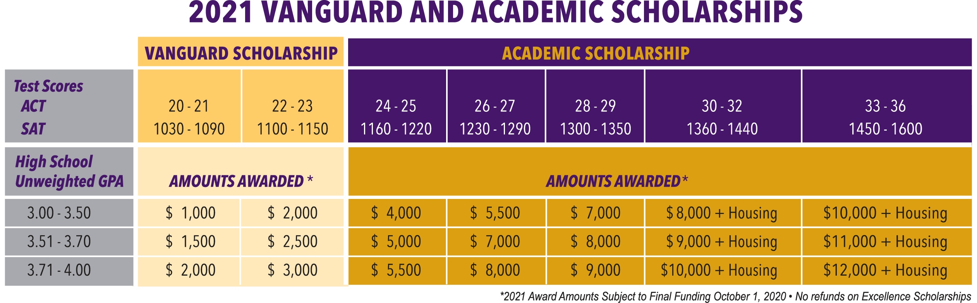

**CAMPUS VISITS**

Individual campus tours are offered Monday-Friday. We ask that each student bring a maximum of two guests and wear a face covering while on campus. There are also options for a virtual campus tour or Zoom chat with your admissions counselor to discuss admissions, scholarships, housing and more.

<https://www.una.edu/visit/index.html>

**IN-STATE TUITION**

$4,800 flat rate for 12-18 hours of coursework

**HOUSING & RESIDENCE LIFE**

Freshmen are required to live on campus.

The housing application will go live on **December 1, 2020**

<https://www.una.edu/housing/index.html>

**QUICK FACTS**

8,000+ students

19:1 student-teacher ratio

170+ Majors

77% of students receive financial aid

College of Business is [AACSB](https://www.aacsb.edu/about/who-we-are) accredited, earned by only 5% of business schools in the world.

14 NCAA D-1 teams

Live lion mascot on campus

Anderson College of Nursing & Health Professions has a 100% NCLEX pass rate for Spring 2020

130+ Student organizations

On campus human performance lab in the Department of Kinesiology

One of the nation’s top-producing institutions for the Fulbright Program

**IMPORTANT LINKS**

**Admissions:** una.edu/admissions

**Athletics**: roarlions.com

**Honors College**: una.edu/honors

**Housing & Residence Life:** una.edu/housing

**Scholarships**: una.edu/financial-aid/scholarships

**Student Engagement Center:** una.edu/students

**Student Financial Aid:** una.edu/financial-aid